Health system leadership is concerned with high rates of ED utilization and the limited reimbursement they receive for this costly service. They are considering launching an initiative to target individuals likely to visit the ED in the next three months for enhanced care coordination and outpatient services. They have asked you to prepare a report that includes:

- Trends in ED visits by month.
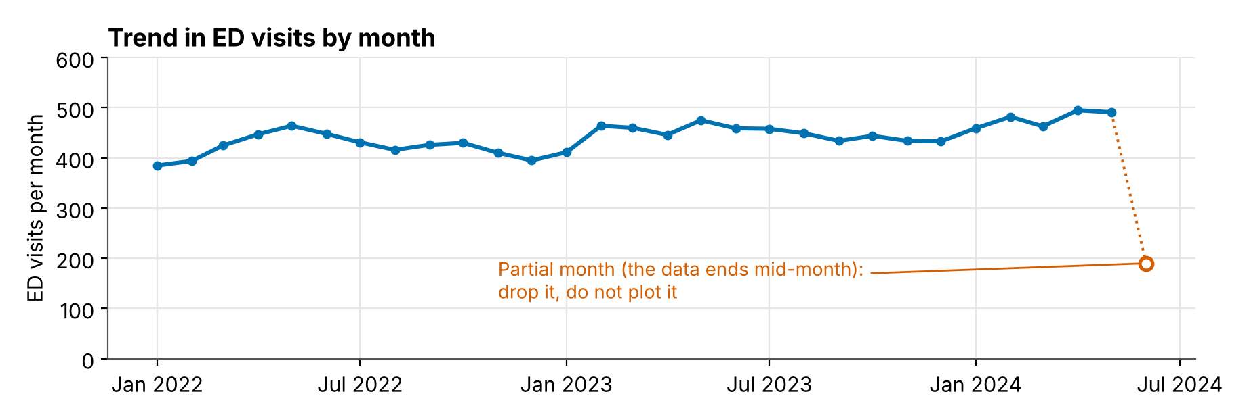
- ED visits by payer because they are substantially concerned about high rates of visits from payers that do not reimburse well.
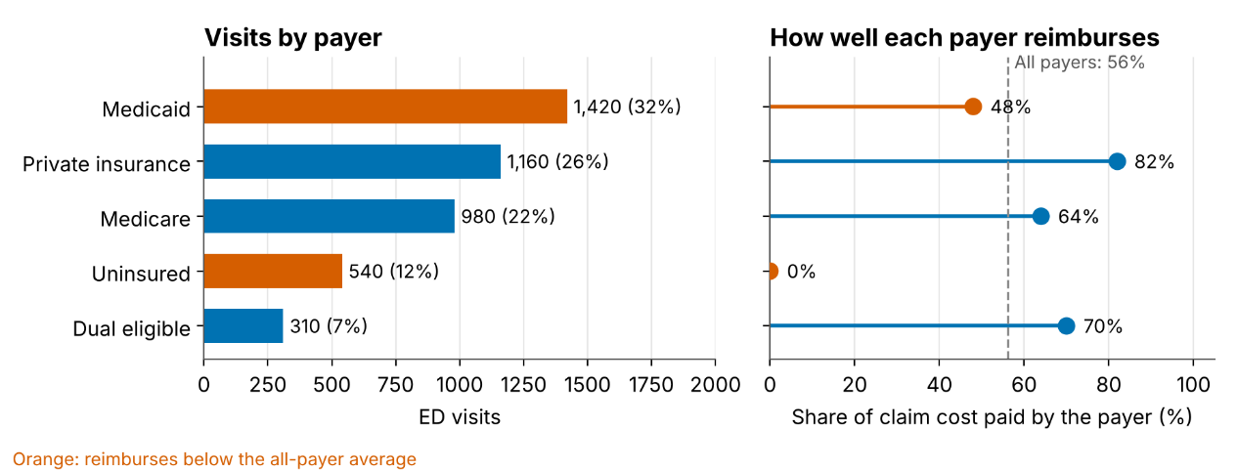
- A Lorenz Curve to identify the degree of concentration in ED costs.
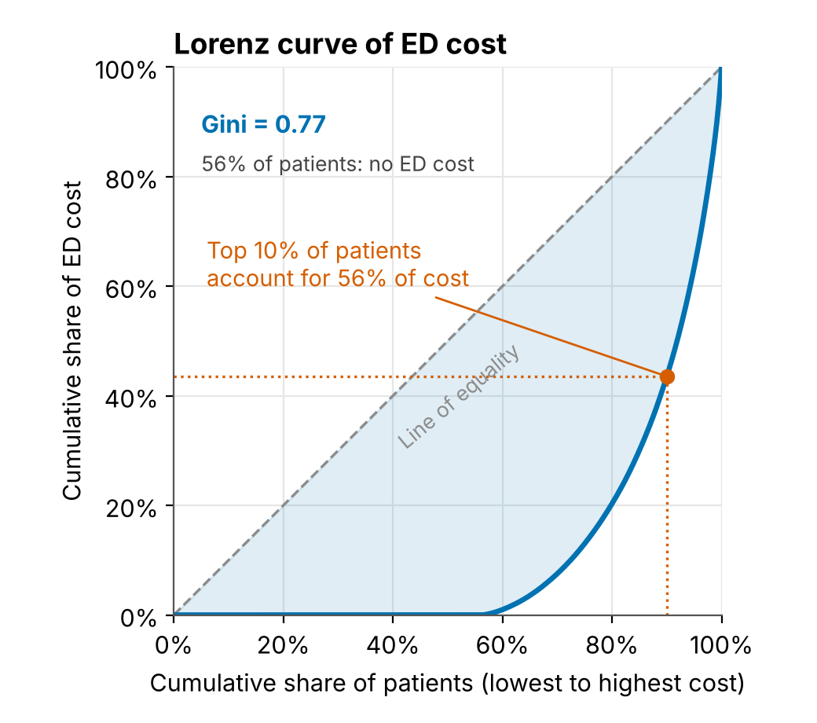
For security reasons, your health system doesn’t like downloading new R packages, so each of these is to be built using standard ggplot. They are also happy with a simple linear probability model.

For each plot consider:
- What Synthea database tables do you need to pull from and what columns?
Deliverable | Tables | Columns
Trends | encounters | id, start, encounterclass
Visits by payer | encounters, payers | encounters.id, payer, encounterclass, total_claim_cost, payer_coverage; payers.id, name
Lorenz | patients, encounters | patients.id; encounters.patient, encounterclass, total_claim_cost

- What shape does the data need to be in to plot it? How will you wrangle it into that shape?
Deliverable | One row per | Columns after wrangling | Key step
Trends | Month | month, ed_visits | Include months with zero visits; drop partial months; count each encounter once
Visits by payer | Payer | payer, ed_visits, share_of_visits, reimbursement_ratio | Label a missing payer; compute the ratio as covered / total cost; sort payers
Lorenz | Patient | cum_patients, cum_cost (from patient_id, ed_cost) | Sort ascending, then cumulative sums and shares; add the (0, 0) point

- What do we need to inspect about the data to ensure our figures are correct?
Deliverable | What to inspect | What you are looking for
Trends | Distinct values of encounterclass;  Visits per month;  First and last month complete;  Visits per patient per day  Unique patient-date encounters | Wrong class included, a partial first or last month, spikes from duplicates
Visits by payer | Distinct payer names;  Missing payer;  Visits by payer add up to total visits;  Payer_coverage versus total_claim_cost | Spelling variants, a null payer, double counting, coverage greater than cost
Lorenz | Share of patients with zero cost;  Distribution of cost;  Negative or missing costs;  Which patients are in the population | Zero-cost patients dropped by mistake, a few huge costs driving the curve

- What do we need to test about our code to ensure it is producing the expected outcome?
Deliverable | Test ideas
Extract | Unique IDs, plausible costs, allowed payers, dates in the window, and zero-cost patients present in the Lorenz extract.
Trends | Duplicate visits are not counted twice.  A month with no visits appears with a count of 0.  The partial last month is dropped.
Visits by payer | Shares sum to 1.  Visits by payer sum to total unique visits.  A missing payer ends up in a labeled category.  The reimbursement ratio is between 0 and 1.
Lorenz | Starts at (0, 0) and ends at (1, 1).  Never rises above the diagonal.  The hand example gives a Gini of 0.48.  Equal costs give a Gini of 0.
Plots | Each plot function returns a ggplot, built from a table with the expected columns.

Structure
Everything we want to test has to be reachable from a test file. That means the work lives in small functions that take data and return data, and the plotting scripts only call them. Functions take data frames or vectors and return data frames, numbers, or ggplot objects. No database calls, file paths, or printing inside them.

Functions
Function (suggested name) | Input, Purpose and output | Data evaluations | Tested for
validate_ed_visits(visits) | Input: Visits table  Output: Visit table, returned unchanged OR an error | Wrong class included,  Partial first or last month excluded,  Duplicates by patient ID and date excluded | Duplicate IDs, negative or missing costs, dates outside the study window
monthly_counts(visits, data_end) | Input: Visits table  Output: One row per complete month (month, ed_visits) | ed_visits sums to initial rows | Duplicates, empty months, partial last month
payer_summary(visits) | Input: Visits table  Output: One row per payer (payer, ed_visits, share_of_visits, reimbursement_ratio) | Spelling variants in payer names;  No missing payer;  Visits by payer add up to total visits; | Shares sum to 1, missing payer labeled, ratio between 0 and 1
lorenz_curve(costs) | Input: Vector of patient costs  Output: A curve table (cum_patients, cum_cost) | Zero-cost patients dropped by mistake,  A few huge costs driving the curve  No negative or missing costs | The fixture gives a Gini of 0.48.  Equal costs give a Gini of 0.  Starts at (0, 0) and ends at (1, 1).  Never rises above the diagonal.
plot_trend(), plot_payer(), plot_lorenz() | The tables above to a ggplot object |  | Returns a ggplot with the expected columns

